“- “: actions

“*”: thoughts or notes

AI Robot Project

**07/04Apr/25-**

-Used the FreeNove Arduino Kit Tutorial to learn about Arduino dc motors and servos.

*Challenge: Even though the design is not mine, the code will be created by me and the robot itself would also be built by me.

Robot ideas:

<https://www.instructables.com/Building-a-Simple-Arduino-Robot/>

chooses this: <https://www.youtube.com/shorts/hWn8QDk0wE4>

-Ordered 4 servos, 4 aa battery holders and an Arduino usb cable.

**08/04Apr/25-**

-Tested the servo code on 180deg servo from FreeNove Arduino Kit Tutorial and found the speed for the legs: delay of 3 ms.

**09/04Apr/25-**

-Tested the servo code on 360deg servo but did not work.

-Looked at codes for 360deg servo from the internet:

<https://www.youtube.com/watch?app=desktop&v=OtOcuJwtPdQ>

pos = 89-95 means stop, pos>95 means ccw, and pos<89 means cw.

**24/05May/25-**

-Thought using a Raspberry Pi 4 and adding AI to it is more interesting than Arduino.

-Researched about power supplies for RPi 4 (battery holders and converters) and ordered heat sink and the supply.

Battery holder and converter: <https://www.amazon.co.uk/dp/B0CJ2LBY94?ref=ppx_yo2ov_dt_b_fed_asin_title>

Heat sink and fan:

<https://www.amazon.co.uk/dp/B07JGNF5F8?ref=ppx_yo2ov_dt_b_fed_asin_title>

**11/06June/25-**

Inspiration for robot design:

<https://tutorials-raspberrypi.com/programming-raspberry-pi-robots-making-it-follow-the-lines/>

-Ordered components from Amazon:

Microphone: <https://www.amazon.co.uk/dp/B0BHYC2MYV?ref=ppx_yo2ov_dt_b_fed_asin_title>

5x battery holder:

<https://www.amazon.co.uk/dp/B07MC7XC15?ref=ppx_yo2ov_dt_b_fed_asin_title>

Camera module:

<https://www.amazon.co.uk/dp/B076FB1KCW?ref=ppx_yo2ov_dt_b_fed_asin_title&th=1>

Short USB C to A Cable:

<https://www.amazon.co.uk/dp/B0D9RGCNLN?ref=ppx_yo2ov_dt_b_fed_asin_title&th=1>

L293D Stepper Motor Drivers:

<https://www.amazon.co.uk/dp/B09TK1RPSX?ref=ppx_yo2ov_dt_b_fed_asin_title>

Chassis:

<https://www.amazon.co.uk/dp/B07F73HY34?ref=ppx_yo2ov_dt_b_fed_asin_title>

**12/06June/25-**

-Used Google AI search to get an idea of how to add Open AI to RPi 4.

-Watched <https://www.youtube.com/watch?v=Cj7NhuLkvdQ> to update Python 3 in RPi4.

-Watched <https://www.youtube.com/watch?v=lHxFFn04L10&t=271s> to implement the speaking chatbot.

-Had problems with pip install “error: externally-managed-environment” so went to <https://forums.raspberrypi.com/viewtopic.php?t=367098> and typed and entered

mkdir my_project

cd my_project

python -m venv --system-site-packages env

source env/bin/activate

and used pip install afterwards.

-Stopped at

**14/06June/25-**

-Deleted my_project directory and redid the installations.

-Followed the comment by Geoffrey by typing the first typing and entering the first line and then following the step 1 of the youtube description.

-Continued debugging the chatbot code.

-Ran the github version but had errors.

-Fixed the first error by removing os.getenv in

api_key = os.getenv("OPENAI_API_KEY").

-Fixed another error my installing an additional library.

<https://stackoverflow.com/questions/40246437/problems-with-gst-in-python-program>

**16/June/25-**

-Ran the script.

-Had rate limit error.

-Added some money to my OpenAI account.

-Reran the script and it worked.

-Terminated the script using Ctrl + Z.

-Tried automatically running script when RPi boots up.

Followed these sites:

<https://www.instructables.com/Raspberry-Pi-Launch-Python-script-on-startup/>

<https://raspberrytips.com/autostart-a-program-on-boot/>

<https://forums.raspberrypi.com/viewtopic.php?t=267113>

<https://linuxconfig.org/how-to-autostart-python-script-on-raspberry-pi>

To find my ip address: 192.168.0.21

-Had audio source error and fixed it by changing audio input to Pro Audio.

-Automatic script when booting worked.

Problem: Sound output for the script is stuck at hdmi when booting.

-Added this exit plan code:

while not done:  
 for event in pygame.event.get():  
 if event.type == KEYDOWN:  
 done = True

Where KEYDOWN = ALT

But didn’t work

**17/06June/25-**

-Made my own script from scratch by reading the library documentations from Thomas Vu Nguyen’s script and taking inspirations from the script itself.

<https://pypi.org/project/openai/>

**20/June/25-**

-Continued making my own script.

-Decided to keep most of Thomas Vu Nguyen’s script but added threads, modified the listen_for_wake_word() into wake_word(), listen_and_respond() into converse(), and overall flow of code.

-Added sleep function so the ai would not input its own response, and “wait” message so the user would wait for the ai to respond.

**25/06June/2025-**

-Added memory allocation and de-allocation for the list messages.

-Added wake_for_silence() function to “sleep” until silence is found to minimise

AI responding to its own voice and forming a loop.

-Removed the break inside sr.UnknownValueError: to simply let it pass to avoid unnecessary return to wake_word() everytime he hears silence quickly.

-Added timing to return the converse() back into wake_word() when a time has elapsed enough.

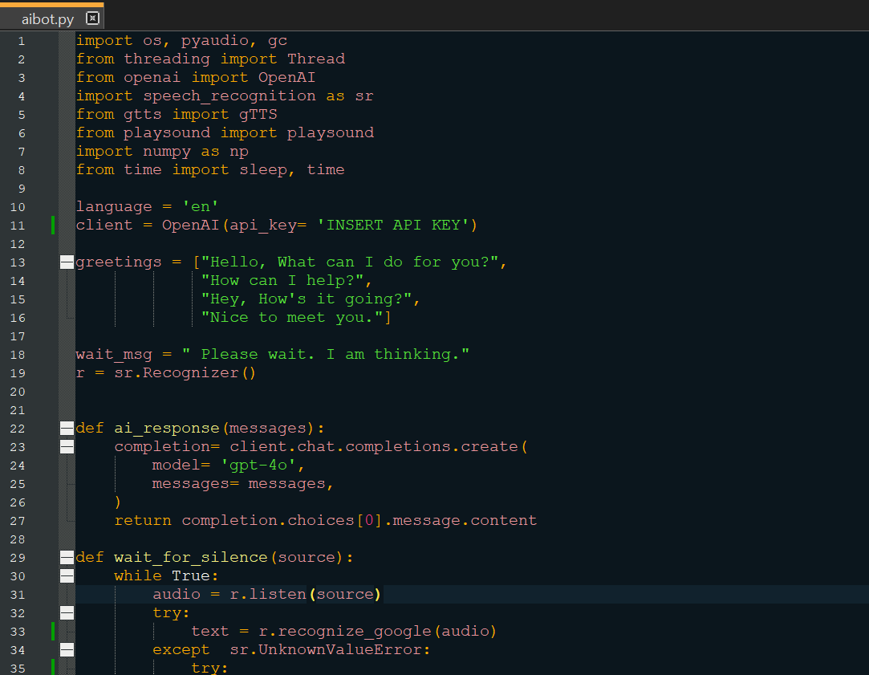

**26/06June/25-**

*AI API for vision inspiration:

<https://cookbook.openai.com/examples/gpt_with_vision_for_video_understanding>

*Getting stream video from camera:

<https://stackoverflow.com/questions/70805012/cv2-videocapture-html-live-stream>

-Typed and entered:

Python3 –m pip install opencv-python

after setting up virtual environment.

And it install opencv-python

**30/06June/25-**

-Completed the vision thread.

-Followed a few websites to fix some small errors.

<https://stackoverflow.com/questions/77284901> to fix a request error about chat completions api inputting a the jpg file.

*Note: Need to reboot or (maybe cam.close()) again camera is used to fix the error about cannot access camera resources to rerun the script.

**01/07July/25-**

-Replaced the de-allocation code block with the function deallocate(memory, max_len)

-Split the list into two global lists: message[] for audio and images[] for vision.

-Vision takes maximum 10 images while audio takes maximum 3 messages(1 dev msg, 1 usr msg, 1 latest image input).

*This should prevent wasteful spending of tokens (unnecessary inputs to AI).

-Tried asking the AI how far away my phone is. It replied and said 1-2 feet (will use this to judge distance for driving)

-Constructed the chassis.

-Read <https://lastminuteengineers.com/l293d-dc-motor-arduino-tutorial/>

for the half-h drivers.

-Adjusted the regulator to output 5V from 7 – 5.5 V input.

The picture above shows the built chassis on the left and the regulator on the right.

**03/07July/25-**

-Tested the new speaker and its volume is better than the previous one.

-Added the wheel control thread and its functions.

-Constructed the breadboard circuit of the motor driver and tested a 3 V dc motor.

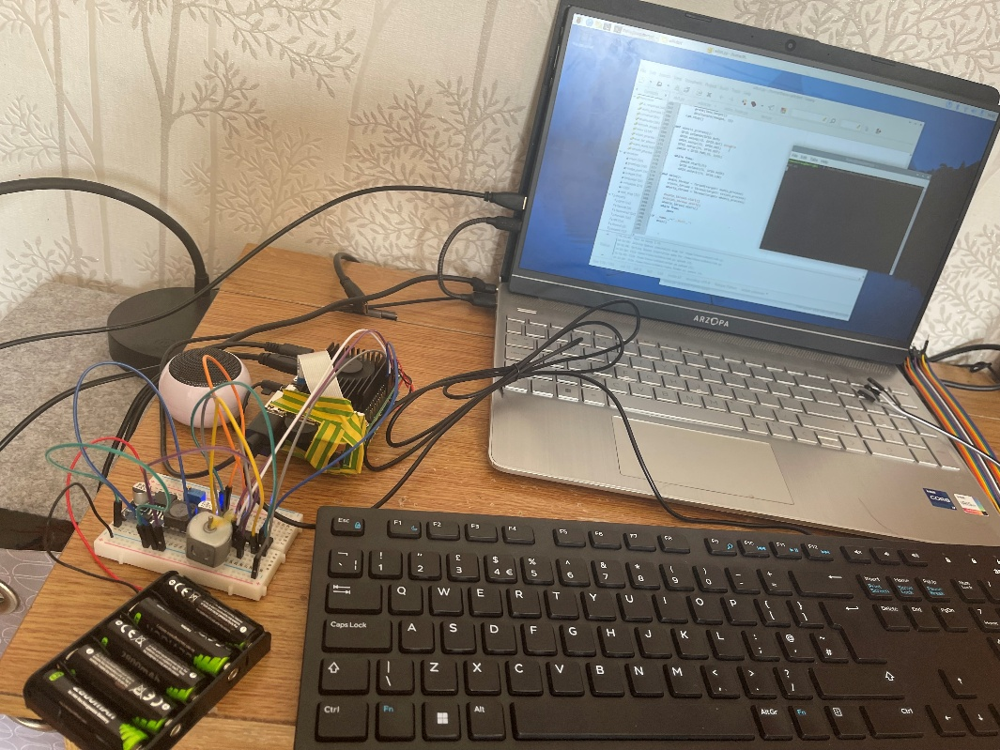

**04/07July/25-**

-Finished constructing the robot.

-Combined vision and wheel control thread.

-Added control_wheels() inside converse().

-Set the developer instructions such that the robot strictly only say the commands to avoid collision.

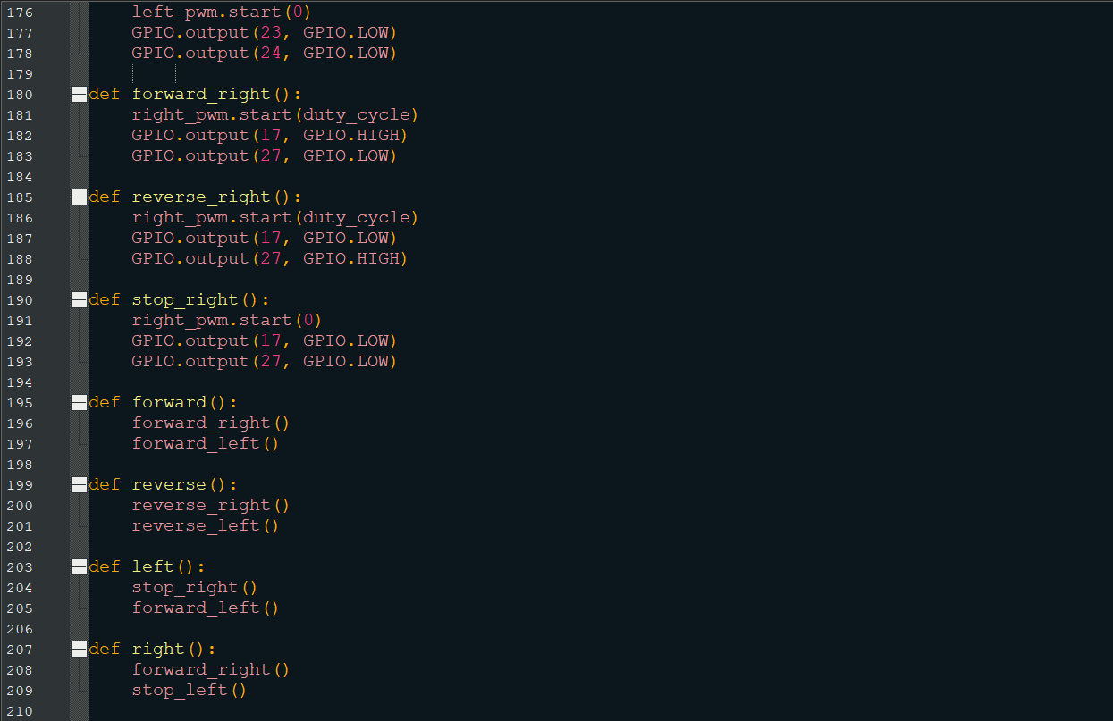

**07/07July/25-**

-Modified the code such that it only adds one image at a time in the messages list to prevent rate limit errors and save tokens.

-Implemented the solution to mute the microphone when the AI is speaking to prevent self-responding.

-Recorded the 2nd demonstration.

**09/07July/25-**

-Removed the sleep() to reduce latency.

-Recorded the 3rd demonstration.

